Week 1 Menu
Each day fresh veggie sticks e.g. carrot, celery, cucumber on offer


Visit the change for life website for healthy recipes that you can make at home at
https://www.nhs.uk/change4life/recipes.
Or why not sign up to their Cook Together scheme. Every week for 4 weeks, they'll send you 2 tasty, healthy recipes with easy to follow instructions, and a shopping list of all the ingredients you'll need to cook a healthy meal. They'll also send you some handy tips about healthier eating and how to be food smart when you're out shopping. Sign up at https://cooktogether.change4life.co.uk/
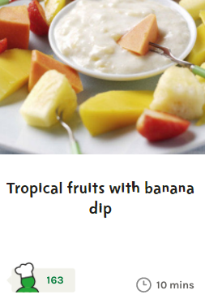
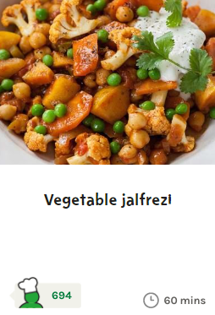
Fish curry, naan bread and rainbow rice and fresh fruit salad.
Why not try making vegetable Jalfrezi and tropical fruits with banana dip at home, from the Change4Life recipes.
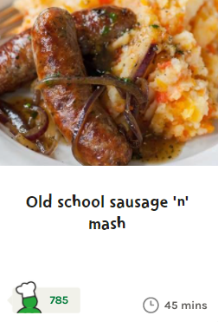
Sausage casserole, creamed potatoes, peas and carrots and scone, strawberries and cream.
Why not try making old school sausage and mash at home, from the Change4Life recipes.
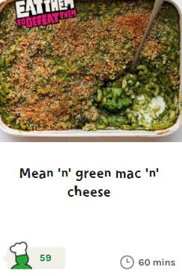
Vegetable lasagne with garlic bread and salad and jam and coconut sponge with custard
Why not try making Mean ‘n’ green mac ‘n’ cheese at home, from the Change4Life recipes.
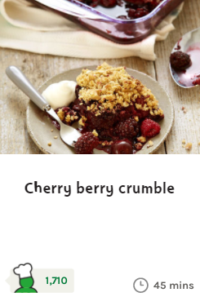
Chicken and mushroom supreme with new potatoes, sweetcorn and runner beans and apple crumble and custard. Why not try making cherry berry crumble at home, from the Change4Life recipes.
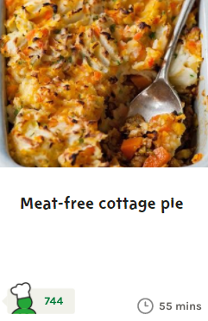
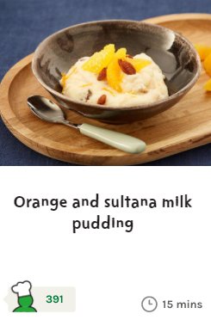
Shepherd’s pie with spring greens and rice pudding with sultanas
Why not try making meat free cottage pie and orange and sultana milk pudding at home, from the Change4Life recipes.
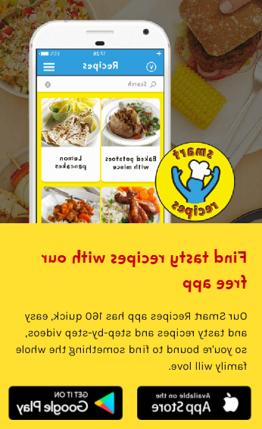
Try downloading the free Change4Life smart recipes app onto your phone

https://www.nhs.uk/change4life/recipes

Please note suitable alternatives are made for any children with specific allergies or dietary requirements.

