Menu Week 3
Each day fresh veggie sticks e.g. carrot, celery, cucumber on offer


Visit the change for life website for healthy recipes that you can make at home at
https://www.nhs.uk/change4life/recipes.
Or why not sign up to their Cook Together scheme. Every week for 4 weeks, they'll send you 2 tasty, healthy recipes with easy to follow instructions, and a shopping list of all the ingredients you'll need to cook a healthy meal. They'll also send you some handy tips about healthier eating and how to be food smart when you're out shopping. Sign up at https://cooktogether.change4life.co.uk/
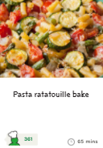
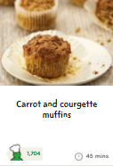
Salmon Pasta Bake with salad and Courgette and Carrot cake with Custard
Why not try making pasta ratatouille bake and carrot and courgette muffins from the Change4Life recipes.
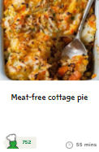
Vegetable Shepherd’s Pie with Swede and Carrot and Fruit Trifle
Why not try making meat free cottage pie at home, from the Change4Life recipes.
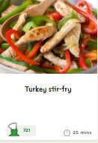
Sweet and Sour Chicken with Rice and Peas and Chocolate Semolina.
Why not try making Turkey stir fry at home, from the Change4Life recipes.
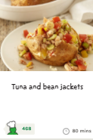
Jacket Potato with Cheese and Baked Beans and Banana with Custard
Why not try making Tuna and Bean Jackets at home, from the Change4Life recipes.
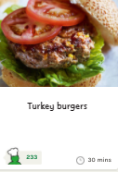
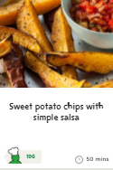
Homemade Burger in a Bun with Potato Wedges and Dark Ginger Sponge with Custard
Why not try making Turkey Burgers and Sweet Potato Chips with Salsa at home, from the Change4Life recipes.
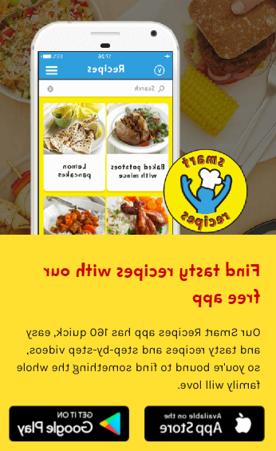

Try downloading the free Change4Life smart recipes app onto your phone

https://www.nhs.uk/change4life/recipes

Please note suitable alternatives are made for any children with specific allergies or dietary requirements.

