Reviewed March 2023
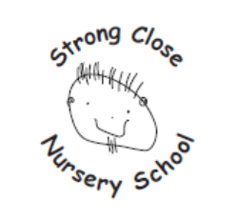
Approved by Governors July 2023

Strong Close Nursery School

Special Educational Needs and Disabilities Policy

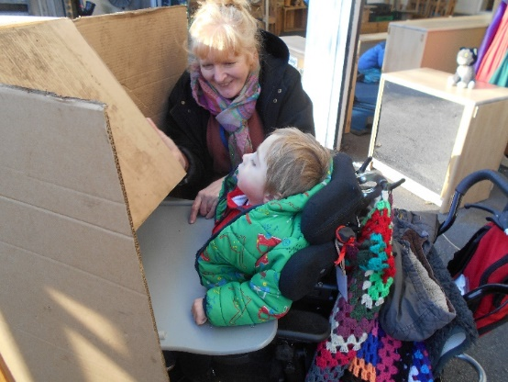
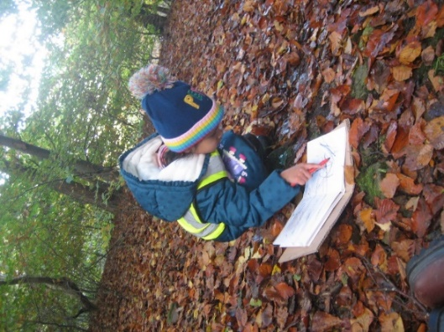

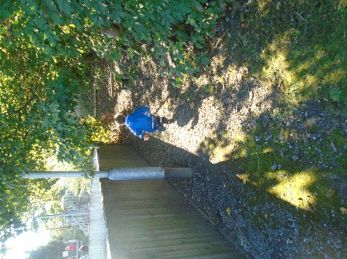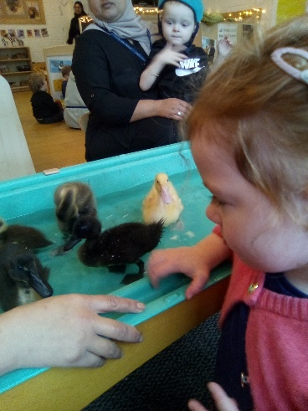

“We all smile in the same language”.

Rationale
At Strong Close Nursery School we respect and enjoy each child’s individuality, providing for differing needs including special educational needs and / or disabilities. We ensure a secure environment and positive experiences are provided to develop a child’s confidence and self-esteem. We help children understand their feelings and express them in ways which do not hurt others. We value parents as partners in their children’s education. It is particularly important in the early years that there is no delay in making any necessary special educational provision. Delay at this stage can give rise to learning difficulty and subsequently to loss of self-esteem, frustration in learning and to behaviour difficulties. Early action to address identified needs is critical to the future progress and improved outcomes that are essential in helping the child to prepare for adult life. We work hard to ensure all pupils become the ‘best they can be’, personally, socially, emotionally and academically in all areas of the curriculum, (regardless of gender,
ethnicity, religion, sexual identity, physical ability or educational needs).

This policy is written to ensure everyone working in our school is clear about the ethos, principles, procedures and practice for pupils with Special Educational Needs and Disabilities (SEND).

This policy has due regard to all relevant legislation including, but not limited to, the following:
- Children and Families Act 2014
- Health and Social Care Act 2012
- Equality Act 2010
- The Equality Act 2010 (Disability) Regulations 2010
- Education Act 1996
- Education Act 2002
- Mental Capacity Act 2005
- Children Act 1989
- The Special Educational Needs and Disability (Amendment) Regulations 2015
- The Special Educational Needs (Personal Budgets) Regulations 2014
- The Special Educational Needs and Disability (Detained Persons) Regulations 2015
- Local Government Act 1974
- Disabled Persons (Services, Consultation and Representation) Act 1986
- Data Protection Act 2018
- The UK General Data Protection Regulation

This policy has due regard to statutory and non-statutory guidance, including, but not limited to, the following:
- DfE (2015) ‘Special educational needs and disability Code of Practice: 0 to 25 years’
- DfE (2015) ‘Supporting pupils at school with medical conditions’
- DfE (2021) ‘Keeping children safe in education (2020)’
- DfE (2018) ‘Working Together to Safeguard Children’
- DfE (2018) ‘Mental health and wellbeing provision in schools’
- DfE (2014) ‘School Admissions Code’

Aims – This is what we intend to do
At Strong Close Nursery School it is our aim:
- To identify special needs and disabilities at an early stage and for these needs to be met within school in order to ensure that all children make good progress.
- To work with the Local Authority in providing Early Years Enhanced Specialist provision places
- To value and build on parents’ knowledge of their children.
- To provide a family friendly environment, establishing positive relationships between child, parents and school.
- To provide all children with an open and accessible introduction to education.
- To offer a wide range of experiences to all children.
- To promote children’s confidence and self-esteem to ensure that they are happy, confident and secure.
- To help children understand their own feelings and needs and those of others.
- To develop positive attitudes amongst all staff, children and parents towards children with special needs.
- To eliminate discrimination
- Promote equal opportunities
- Foster good relationships between children with SEND and children without SEND.
All children and young people are entitled to an education that enables them to make progress so that
they achieve their best; become confident individuals; live fulfilling lives and make a successful transition into adulthood, whether into employment, further or higher education or training (Section 6.1 SEND Code of Practice)

Objectives – This is how we implement our aims
This policy aims to fulfil the ambition of Strong Close Nursery School which is to enable all
children, regardless of their ability, to achieve their potential and to thrive in an enabling environment.

- To ensure effective management of SEND through an identified Special Educational needs co-ordinator
- To support early identification of needs through initial entry assessment.
- To establish and foster partnerships with parents through the key person system, home visits, parental involvement in initial and ongoing assessment. Key persons or SENDCO will meet termly to discuss progress and parents contributions to the record of achievement. Parents of children with SEND will be encouraged to share their knowledge of their child; the Headteacher, SENDCO and teachers will aim to give them the confidence that their views and contributions are valued and will be acted upon.
- To help the child and parent feel secure about the transition from home to nursery and welcome the parents presence in the classroom to support their child during the initial settling in period.
- To create an inclusive environment that offers a range of experiences and resources which are accessible to all children and which value and extend their home experiences.
- To place concerns about individual children and special needs on the agenda of staff meetings in which individual children’s progress and needs are discussed during weekly meetings.
- To value and celebrate a child’s achievements through assessments and observations.
- To support children’s ability to express themselves and respect others.
- To identify and meet the professional development needs of staff in respect of special needs. Staff will keep up to date with any necessary training, which will be provided by the SENDCO, a well as external agencies. The training offered will be delivered to ensure equality, diversity, understanding and tolerance.
- To support parents understanding of nursery education through displays, booklets and discussions which chart their own child’s progress through different stages of development in the EYFS and Developmental Journal.
- To work collaboratively with other professionals/agencies with the aim of working together to effectively support children’s needs.
- To work with the Local Authority and provide them with information regarding our existing SEND provision and capabilities to support children with SEND.
- Sign post parents and families to outside agencies that can support their child’s needs. See appendix 3 for list of useful contacts.

Identifying SEND
Identification is made by staff through:
- Observing children’s learning and emotional needs on a daily basis.
- Staff working in collaboration with parents and families to form a full picture of the child.
- Termly assessments
- Sharing concerns with the SENDCO as soon as possible
- Professional dialogue between parents, the child’s teacher, key person, the SENDCO and outside agencies such as Speech and Language Therapists.
Parents are consulted at every level of the intervention. Action is then taken to put effective support in place. This is known as the graduated approach. This meets the child’s needs by;
- Establishing a clear assessment of the child’s needs.
- Planning, with the child’s parents, the strategies and support put in place, as well as the expected impact on progress, development and behaviour, along with a clear date for review.
- An Individual Support Plan (ISP) is written by the class teacher and strategies implemented with support from the SENDCO.
- Reviewing the effectiveness of the support strategies and making necessary revisions.
Definitions
A pupil has SEND if they have a learning difficulty or disability which calls for special educational provision to be made for them.
They have a learning difficulty or disability if they have:
- A significantly greater difficulty in learning than the majority of the others of the same age, or
- A disability or health condition which prevents or hinders them from making use of educational facilities used by the peers of the same age in mainstream schools.
Under the Equality Act 2010, a disability is a physical or mental impairment, which has a long term and substantial adverse effect on a person’s ability to carry out normal day-to-day activities.

Assessment

In consultation with the child’s parents, Strong Close Nursery School will, request a statutory assessment of SEND where the child’s needs cannot be met through the resources normally available within the school.

Consideration of whether SEND provision is required, and thus an EHC plan, will start with the desired outcomes and the views of the parents and child.

The school will meet its duty to respond to any request for information relating to a statutory assessment, within six weeks of receipt.

The school will gather advice from relevant professionals about the child concerned, including their education, health and care needs, desired outcomes and any special education, health and care provision that may be required to meet their identified needs and achieve desired outcomes.

In tracking the learning and development of children with SEND, the school will:
- Base decisions on the insights of the child’s parents.
- Set children challenging targets.
- Track children’s progress towards these goals.
- Review additional or different provisions made for them.
- Promote positive personal and social development outcomes.
- Base approaches on the best possible evidence and ensure that they are having the required impact on progress.

Detailed assessments will identify the full range of the individual’s needs, not just the primary need.

Where possible, children’s needs will be defined under the ‘Special educational needs and disability Code of Practice: 0 to 25 years’ broad areas of need:
- Communication and interaction
- Cognition and learning
- Social, emotional and mental health difficulties
- Sensory and/or physical needs

Where a child continually makes little or no progress, or is working substantially below expected levels, the school will consult with parents before involving specialists.

Review
During the termly reviews it may be decided that
- The child may be considered no longer to have any special educational needs
- Intervention may need to continue at this stage
- Interventions may need to be adapted
- Help from external agencies as well as further intervention is required.

Enhanced Specialist Provision
Our specialist provision include children with a range of special educational and medical needs. All the children have access to our mainstream nursery provision as well as a quiet learning space and sensory room.
The provision has a specialist teacher and experienced specialist practitioners who have a wide range of skills which are used to support each child to develop their full potential.
Children who attend our specialist provision have a higher staff to child ratio within the nursery. This means that the children are able to spend time 1:1 with adults or play in small groups.

Places with our enhanced specialist provisions are allocated through consultations with the local authority.
Supporting children with health needs who are unable to attend school
At times, children with complex physical and medical needs may need to be absent from school.
Strong Close Nursery School will ensure that;
- Children’s key persons and the SENDCO keep in contact with families via phone calls, home visits, emails and regular Facebook updates. This will be organised on an individual basis.
- Children and families receive updated copies of their ISP’s detailing their learning objectives each term.
- Home learning packs sent to families with activities linked to current learning in school.

Supporting children with medical conditions
Strong Close Nursery School will;
- Support children at school with medical conditions so that they have full access to education, including school trips.
- Ensure that arrangements are in place in schools to support pupils at school with medical conditions.
- Ensure that they work with health and social care professionals, pupils and parents to ensure that the needs of children with medical conditions are properly understood and effectively supported on a termly basis.

Promoting Health and Well-being
Strong Close Nursery School will ensure that there is;
- A focus on promoting children’s resilience, confidence and ability to learn in all areas across the EYFS curriculum.
- Positive classroom management and working in small groups will be implemented to promote positive behaviour, social development and high self-esteem.
- Specialist services available where a child requires such services.
- Where appropriate, the school will support parents in the management and development of their child.
- The school will focus on work that helps to build self-esteem and self-regulation strategies

Roles and Responsibilities

The SENDCO will:

• Work with the Headteacher and SEND governor to determine the strategic development of the SEN policy and provision in the school

• Have day-to-day responsibility for the operation of this SEND policy and the co-ordination of specific provision made to support individual pupils with SEND, including those who have EHC plans

• Provide professional guidance to colleagues and work with staff, parents, and other agencies to ensure that pupils with SEND receive appropriate support and high-quality teaching

• Advise on the graduated approach to providing SEND support

• Advise on the deployment of the school’s delegated budget and other resources to meet pupils’ needs effectively

• Be the point of contact for external agencies, especially the local authority and its support services

• Liaise with potential next providers of education to ensure that the school meets its responsibilities under the Equality Act 2010 with regard to reasonable adjustments and access arrangements

• Ensure the school keeps the records of all pupils with SEND up to date

The SEND governor will:

• Help to raise awareness of SEND issues at governing board meetings

• Monitor the quality and effectiveness of SEN and disability provision within the school and update the governing board on this

• Work with the Headteacher and SENDCO to determine the strategic development of the SEND policy and provision in the school

The Headteacher will:

• Work with the SENDCO and SEND governor to determine the strategic development of the SEND policy and provision within the school

• Have overall responsibility for the provision and progress of learners with SEN and/or a disability

Class teachers

Each class teacher is responsible for:

• The progress and development of every pupil in their class

• Working closely with any teaching assistants or specialist staff to plan and assess the impact of support and interventions and how they can be linked to classroom teaching

• Working with the SENDCO to review each pupil’s progress and development and decide on any changes to provision
• Ensuring they follow this SEND policy
Monitoring and review
This policy is reviewed on an annual basis by the SENDCO and Headteacher in conjunction with the Governing body; any changes made to this policy will be communicated to all members of staff, parents of children with SEND, and relevant stakeholders.
The next scheduled review date for this policy is March 2024
Reviewed by Laura Ross – SENDCO and Janine Martin – Parent Governor.

The following support the implementation of this policy and ensure we monitor impact

Curriculum policy
Safeguarding and Child protection policy
Equalities Policy
Behaviour Policy
Accessibility Plan
SEND Information Report

